
Company
Logotype

Cone Beam Computed Tomography- Report



Porur Dental X-rays & CBCT

Patient Name : Mr. Karthik | Date of Report : 14.03.2024
Age/ Gender : 29 years/ Male | Region of Interest : CBCT Mandible
Referring doctor: Dr. Jeeva | Indication : Cyst in relation to right side of mandible
Clinical Notes: Nil
PATIENT INFORMATION

CBCT Mandible provided
CBCT – IMAGE DETAILS

RADIOGRAPHIC INTERPRETATION

- Completely missing crown and root portion in relation to 48.
- In relation to the 4th quadrant, presence of a single, expansile, unilocular, hypodense area bounded by a corticated margin measuring 14.09 x 14.83 x 14.25mm in dimension.
- The hypodense region appears to be in contact with the inferior alveolar nerve canal, appears to push the canal buccally and appears to cause mild bucco-lingual expansion.
- The lingual cortical bone is present with extreme thinning and is present with areas of discontinuity and obliteration.

RADIOGRAPHIC IMPRESSION

- Differential Diagnosis (based on the visible radiological features): Benign Odontogenic cyst/ tumor in relation to the right mandibular alveolar ridge.


Kindly correlate with clinical and histopathological features

IMAGES FOR REFERENCE

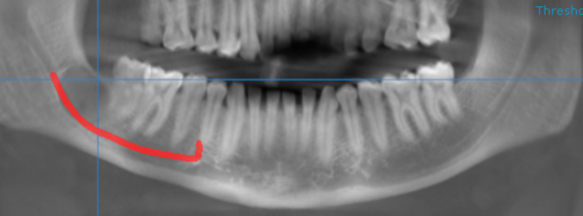
single, expansile, unilocular, hypodense area bounded by a corticated margin
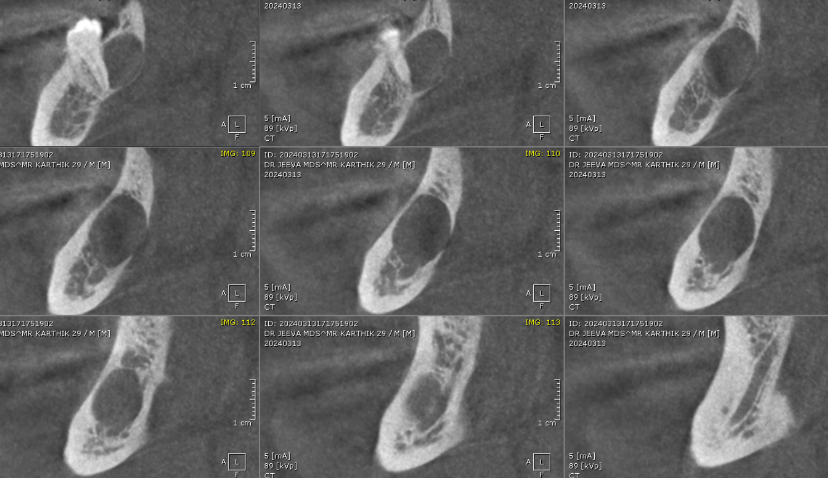
SAGITTAL IMAGES FOR REFERENCE

CORONAL IMAGES FOR REFERENCE
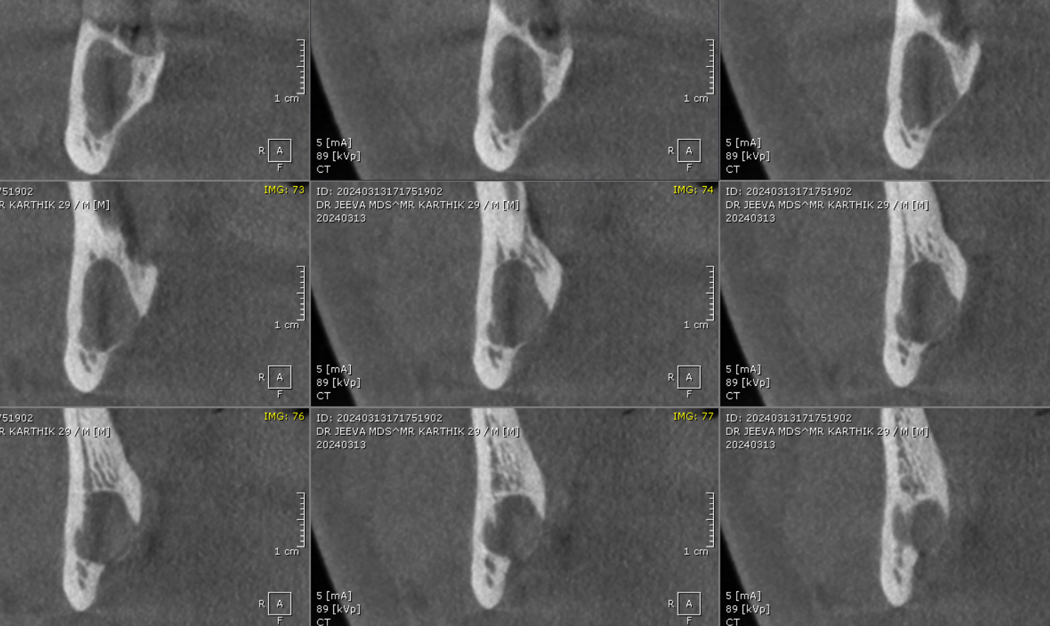

3-DIMENSIONAL VIEW

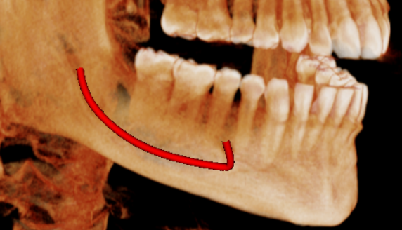

**** End of report ****

